## Breakout Room Activity – Leadership Philosophy Canvas

Kaiser Thrive Local Capacity Development Grants

Session 2: Authentic Leadership

**Purpose:**

This activity helps participants create their leadership philosophy and fosters a deeper understanding of the principles of Authentic Leadership.

**Benefits of Developing a Leadership Philosophy:**

A leadership philosophy is a foundational tool that supports effective and authentic leadership. Developing a leadership philosophy has several benefits:

* **Clarity and Direction** – It helps leaders clearly define your values, principles, and beliefs about leadership, providing a consistent direction for your actions and decisions.
* **Consistency** – A well-articulated leadership philosophy ensures that the leadership approach remains consistent, which builds trust and reliability among the team members.
* **Self-Awareness** – It encourages deep self-reflection, helping leaders understand the strengths, weaknesses, and areas for improvement, which is crucial for personal growth and authentic leadership.
* **Communication** – Provides a framework for communicating the leader’s leadership styles and expectations to others, fostering better understanding and alignment within the team.
* **Decision-Making** – Having a clear philosophy guides your decision-making process, ensuring that your choices align with core values and long-term goals.
* **Motivation and Inspiration** – It can serve as a source of motivation and inspiration, both for yourself and for those you lead, by clearly articulating your vision and purpose.
* **Resilience** – In challenging times, a strong leadership philosophy can act as an anchor, helping leaders stay grounded and focused on their principles.
* **Trust** – Reinforces trust, creating trusting relationships providing the opportunities for the team to be more creative, collaborative, and empower them to reach their full potential.

**Key Elements of Authentic Leadership**

**Reference Slides:**

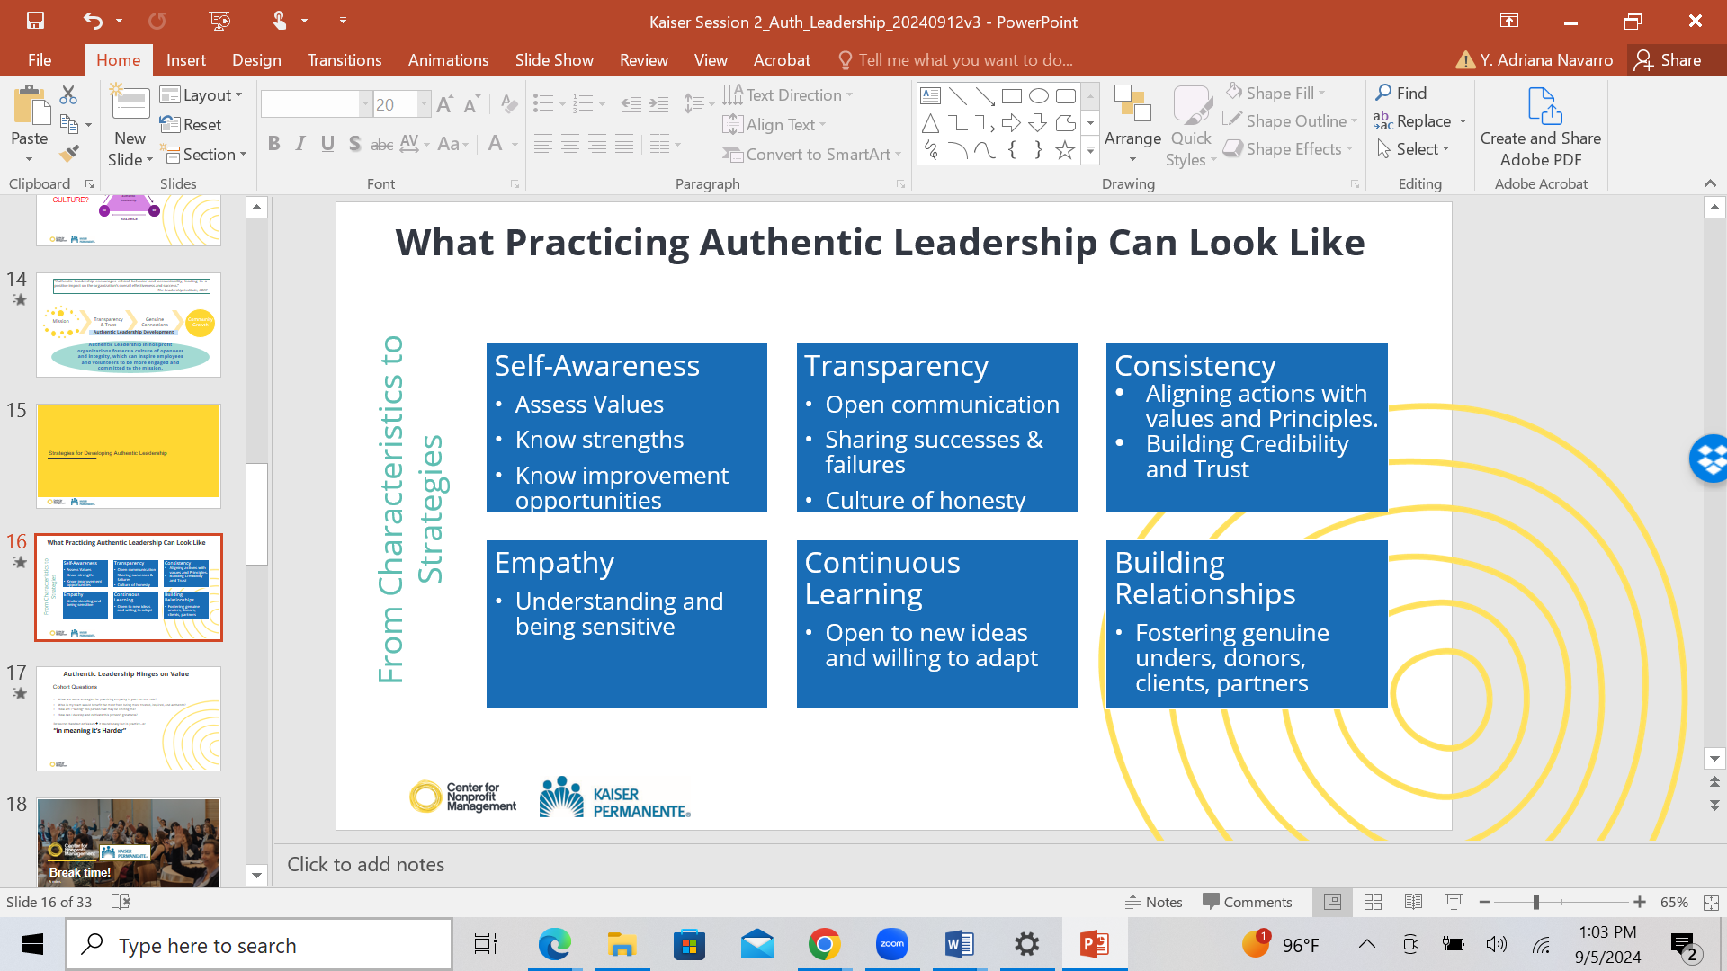

**Zoom Breakout Room TASK – 20 minutes** (4 people groups)

**Developing Your Leadership Philosophy Canvas - Instructions**

1. Use the “Leadership Philosophy Canvas” template – in this handout.
2. In your group:
   1. Independently go to Step 1 and answer the questions on values informed by the pre-work assignment.
   2. Go through each step to understand the 7 steps of crafting the language for your leadership philosophy.
   3. Identify which step is the easiest for you to answer. What feels harder? Explain why.
3. **After this session, schedule time and fill out the template.**

## Developing Your Leadership Philosophy Canvas

**Step 1: Self-Awareness**

Reflect on and write down your core values in order of importance and how these influence your leadership style – copy your top 5 core values from your *Session 2: Authentic Leadership Pre-Workshop Activity.*

My Top 5 Core Values:

1.

2.

3.

4.

5.

How do these core values influence your leadership style?

**Step 2: Transparency**

Discuss and note below how you can incorporate or enhance transparency into your leadership practices?

In the space below, note some specific **actions** and **behaviors** you want to practice to be more intentional about your transparency practices

|  |  |
| --- | --- |
| Actions | Behaviors |
|  |  |
|  |  |
|  |  |
|  |  |
|  |  |

**Step 3: Consistency**

Identify ways you can ensure consistency in your decisions and actions. You are highly encouraged to think of and expand on real-life examples.

**Step 4: Empathy**

Share strategies for practicing empathy in your leadership roles. Write down specific instances where empathy made a difference.

**Step 5: Continuous Learning**

Reflect on how you can stay committed to continuous learning. List resources or activities that support your growth.

**Step 6: Building Relationships**

Write down methods for building, enhancing, and nurturing strong relationships within your teams. Write down any key strategies that you are already implementing with your teams.

**Step 7: Write your leadership philosophy statement taking the most relevant highlights from Steps 1 – 6 from this activity. The product of Step 7 is YOUR Leadership Philosophy.**

**Step 7:** Write your leadership philosophy statement taking the most relevant highlights from Steps 1 – 6 from this activity. The product of Step 7 is YOUR Leadership Philosophy.

**Conclusion & Application Strategies**

You are highly encouraged to continue refining your leadership philosophy and to apply these principles in your daily leadership roles. Some application strategies for your leadership philosophy are:

1. **Coaching** – Modeling your philosophy during formal and informal coaching sessions, this provides you with opportunities to practice articulating your leadership philosophy and an opportunity to guide others into creating their own.
2. **Communication** – Clearly articulating your philosophy to you team so they understand your values and expectations.
3. **Decision-making framework** – Applying your philosophy as a framework for making ethical and strategic decisions.
4. **Feedback** – Encouraging and incorporating feedback from your team to refine and improve your leadership approach.

* 360-review assessments
* Performance management process
* One-on-One check-in meetings

1. **Interviews** – Using your philosophy to support your personal branding and stand out during interviews with potential employers and or clients.
2. **LinkedIn Profile** – Incorporate a brief summary of your leadership philosophy in your LinkedIn Profile to stand out and attract impactful connections.
3. **Mentorship** – Using philosophy to guide and mentor emerging leaders within your organization or outside of your organization.
4. **Strategic Retreats** – Incorporate your philosophy in your strategic planning retreats, adding it to presentations, and expanded professional narratives.

These strategies can help ensure that your leadership philosophy is not just a statement, but a practical guide that shapes your actions and interactions leading you to win-win solutions.

**Activity Credits**

This is a blended approach activity adapted from the following resources:

1. [Harvard Business Online](https://online.hbs.edu/blog/post/authentic-leadership) – Leadership Section
2. “Trust & Inspire” by Stephen M. R. Covey. (2022)
3. “Dare to Lead: Brave Work. Tough Conversations. Whole Hearts. (2018)